The State of Our Waters

UK water pollution is now highly publicised
There has been a recent surge in public awareness of poor surface water quality in the UK, and in particular the sewage discharges made by our water and sewerage companies (WaSCs) (Kachev, 2024). Stantec (2021) explain that 36% of whom they surveyed view water pollution as one of the 3 most important environmental issues facing the UK.
This increased media coverage and public awareness seems heightened compared to other developed countries. Engineering services company Jacobs (2022) suggests CSO discharges are subject to stronger public attention and scrutiny in the UK compared to the EU, despite the UK investing more into CSO management than EU comparators. Figure 1 presents media interest in sewage spills in London compared with New York, represented by search results from LexisNexis. We see that after 2020, the number of UK articles published concerning sewage spills in London starkly increases, exceeding the number from the US about New York. The upward trend is not observed in the US, evidencing the unique recent public reaction in the UK to CSOs.

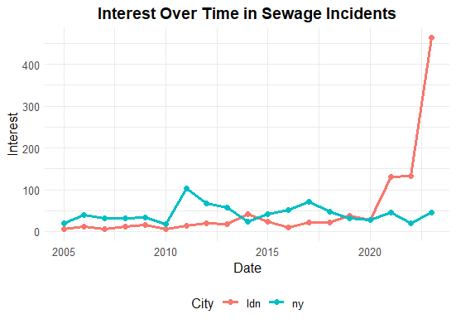
Figure 1
UK waters have poor environmental performance
The stronger public attention towards CSOs and sewage contamination in the UK compared to other developed countries coincides with UK waters’ poor environmental performance compared to the EU (Aqua Tech, 2022). Data suggests only 14% of UK rivers have “good ecological status” (Newson, 2024). Most individual tests that contribute to a waterbody’s overall ecological status are passed (79%) by surface waterbodies, but a waterbody needs to pass all relevant tests to be considered to have good ecological status (Environment Agency, 2024). Certain conditions are common causes of failure: fish, morphology and phosphorus all have rarely met ecological requirements (Newson, 2024).
In addition to few surface waters having good ecological quality, none have good chemical status according to the latest data from 2019 (ibid). This relates to the inclusion of requirements for uPBT (ubiquitous, persistent, bioaccumulative, toxic) substances which are increasingly posing risks to river health (Environment Agency, 2024). We note that not including these uPBTs – certain persistent chemicals that can be toxic to living organisms – would mean 93% of surface waterbodies would pass, showing their impact (Environment Agency, 2024). Meanwhile in the EU, countries like France have been seeing increases in the proportion of bathing sites designated excellent for water quality (European Union [WISE], [accessed 2024]). 30% of EU surface waters have good chemical quality (European Environment Agency, 2024) and around 40% have good ecological quality (European Environment Agency, 2021). These figures are notably higher than what we observe in the UK, indicating that the stronger public reaction in the UK may be a consequence of the poorer water quality here. Furthermore, with respect to river and coastal bathing waters specifically, the UK lags behind all but 5 EU nations (Swindells, 2022).

UK waters suffer more than others from sewage discharges
The media attention towards CSO discharges may suggest that sewage discharges made by UK WaSCs cause the distinction in surface water quality between the UK and other comparable nations. The UK has a high prevalence of combined sewers, due to large urban development in the UK preceding the mid 20th Century when these sewer systems were the standard approach (Stantec, 2021). The UK has in total 15,000 CSOs, of which 13,350 discharge into inland rivers (Newson, 2024). The water industry failed to meet its 2020 targets of a 50% reduction in serious pollution incidents from the 2012 level (House of Commons, 2022). Discharges are becoming more routine, including in dry conditions (Newson, 2024) and the under capacity of the English wastewater systems is a cause of this (Voulvoulis & Giakoumis, 2023). European nations often don’t face the same issue, as they have fewer combined sewers proportionally: France has 32% combined sewers; Germany 43% (Milieu, 2016). The Netherlands, however, has a similar proportion of CSOs to the UK (around 70%), so it is justified to compare the two countries’ waters (ibid).
Research from Wagenigen University suggests that the Netherlands has the poorest surface water quality of the 27 EU member states, with only around 1% of its rivers meeting EU cleanliness standards (Wagenigen University, 2023). Partially, this is due to the Netherlands’ geography meaning it receives polluted water from other European nations upstream (ibid). Although both the UK and Netherlands have a poorer surface water quality compared to most other European countries, their capital cities have starkly different water outcomes. Bathing is common in Amsterdam waters, and is deemed safe (Radu, 2023) with brown tint typically resulting from silt (Bloomberg, 2024). Sewage overflows are rare, typically occurring around 4 times yearly (Waternet, [accessed 2024]), and on these occasions a warning will automatically be issued to inform swimmers not to use the waters for at least 48 hours (Bloomberg, 2024). Sewage overflows are much more routine in London. According to 2023 Event Duration Monitoring data from the Environment Agency, Thames Water made 16990 combined sewage discharges, as counted by the 12 24 method.

London is investing more to mitigate CSOs than other cities, but climate change may make the solutions temporary
Sewage spills used to be a much bigger problem across Europe, which, coupled with industrial pollution, made waters in capital cities unsafe for swimming in the 20th Century (Bloomberg, 2024). Many major cities seem to have invested heavily in their wastewater systems, such that there is a trend toward urban swimming across continental Europe (ibid). The highly publicized £1bn cleaning project of the Seine has transformed the Parisian river ahead of the 2024 Olympic Games (Barradale, 2024). The main element of the clean-up effort was the construction of a large rainwater storage tank, able to hold excessive runoff water to prevent sewers from overflowing (Rollins School of Public Health, 2024). The American city of Atlanta successfully implemented a similar strategy to combat its sewage issues (ibid). Although London may see more combined sewage overflows than other major cities such as Amsterdam, it is not without infrastructure investments like Paris or Atlanta. £4.5bn was spent to construct a 25km “super sewer” under the Thames (Barradale, 2024) to divert pollution from 34 CSOs away from the river. The UK water industry claims it could reduce sewage spills into the river by 95% (Water UK, 2023). There are some concerns with the strategy of increasing storage in combined sewer systems to prevent water pollution. We observed that heavy rainfall prevented the Seine being safe for some Olympic events (Barradale, 2024) and furthermore, climate change – through increased frequency of heavy storms – poses the risk that these larger sewers will not be enough to prevent problems in the future (Rollins School of Public Health, 2024).
Instead, more comprehensive approaches to upgrading combined sewer systems can be taken. Washington DC, which is one-third served by combined sewers (United States Environmental Protection Agency, 2017), has taken on a 20 year, $2.7bn infrastructure project, the Clean Rivers Project (Schnabel Engineering, [accessed 2024]). Beyond involving 4 major tunnels to provide additional capacity to the combined sewer system (ibid), the project also involves green infrastructures at DC facilities to reduce the amount of stormwater entering the sewers (DC Water 2024). These include bioretention facilities and permeable pavements that will help keep the sewers operating effectively with the less predictable and extreme weather resulting from climate change (Sidara Collaborative, 2024). The UK could apply these emerging technologies to help prevent sewer overflows in cities like London. However, it should be noted that, even if sewer overflows can be prevented, there are important other sources of water pollution to consider (Barradale, 2024).

Agricultural diffuse pollution is also a significant problem, especially with concerns over certain persistent chemicals
Data from the UK and EU show the agricultural industry holds significant responsibility for the pollution of our surface waters. As aforementioned, uPBTs are the primary cause for waterbodies failing to achieve good chemical status (Environment Agency, 2024). Often these chemicals come from agriculture; for example, cypermethrin, highly toxic to aquatic organisms such as fish, is an insecticide widely used in arable farming, although its use has been falling (Environment Agency, 2019). In addition, nitrates and phosphates, from fertilisers, pose ecological issues for waterbodies (Environment Agency, 2024) and microplastics in sludge used by farmers is a growing concern for pollution (House of Commons, 2022). These figures help to explain why pollution from rural areas is the largest cause of pollution to rivers, affecting 40% of waterbodies, compared to 36% and 18% from wastewater and urban diffuse sources respectively (Newson, 2024). In the UK, there is growing media attention on the role of agriculture in water pollution, although there is not such a pronounced surge in recent years as we observe for sewage discharges (see A2). There are government regulations in place, but poor understanding and low compliance coupled with the difficulty in monitoring and tracing the sources of diffuse pollution hinder impacts (Wentworth & Peck, 2022).
This issue is not unique to the UK; agricultural diffuse pollution is a notable pressure on water quality globally (Taylor et al, 2016). From the 2nd RBMPs in Europe, the biggest pressures on surface waterbodies in the continent are from diffuse sources, and in particular, agriculture (Office for Environmental Protection, 2023). The Netherlands has struggled to keep up with the European Water Framework Directive due to surface waters containing too many fertilizers and pesticides (Wagenigen University, 2023). Most nations have delayed their targets for good ecological status of surface waterbodies from 2027 until 2063, mainly due to the identification of new uPBTs – which are often related to agriculture (Office for Environmental Protection, 2023). The UK, it seems, has a bigger problem with its capital’s waterbodies and with sewage than other comparable countries, but faces many of the same challenges regarding agricultural and urban diffuse pollution.

Urban diffuse pollution is of growing concern, and governments are working on local initiatives to tackle it
Both the UK and EU acknowledge the growing pressure on waterbodies from diffuse urban pollution, that will likely get worse with population growth and climate change (Environmental Protection Agency, 2019; European Commission, 2022). Often issues involve misuse of drains, misconnections and urban runoff (Environmental Protection Agency, 2019). There are difficulties in addressing the issue, given how hard it is to trace the source of any pollution so often the intention of governments is to work with local bodies to create targeted interventions, such as information provisions (Environmental Protection Agency, 2019; European Commission, 2022).

There are positive goals for the future of UK waters
A positive sign for UK waters is the growing transparency in CSO data provided by WaSCs: there is good monitoring with all CSOs monitored since the end of 2023 (Newson, 2024) and the water companies are now starting to comply with the Environment Act of 2021 in publishing live maps that show discharges (Rivers Trust 2024). CSO data transparency is seen as an important component of the comparatively well managed combined sewer system in the USA (Jacobs, 2022).
Furthermore, there exists regulation that commits to certain water quality targets, such as reducing phosphate concentrations by 40% by 2038 compared to the 2018 baseline (Newson, 2024). There are regulations requiring WaSCs to only allow discharges when they can evidence there is no adverse ecological impact by 2050, demonstrating the intention for reducing pollution from wastewater, and there are legal requirements on necessary upgrades the water companies must make, which are expected to cost around £56bn (ibid). Initiatives to tackle diffuse pollution include provisions of funds to help farmers store slurry and restrictions on certain plastics and forever chemicals (ibid).
Meeting these ambitions will require careful regulation of water companies, who have been found to have not been complying with existing Environment Agency regulations regarding wastewater treatment (Newson, 2024). There will be difficulties, especially given the Office for Environmental Protection regard the government as being largely off track in meeting its targets for water so far (ibid). Much of the UK law regarding sewage discharges is derived from EU law, and the Water Framework Directive has been expensive and difficult for many member states to keep up with (Institute for European Environmental Policy, 2024).

References
Aqua Tech. (2022) Is Briton falling behind EU with combined sewer overflow plan? [online] Available from: https://www.aquatechtrade.com/news/utilities/new-uk-combined-sewer-overflow-plan (Accessed 30/08/2024)
Barradale, G. (2024) Could London follow Paris’ Olympic efforts and make River Thames clean enough to swim? [online] Available from: https://www.bigissue.com/news/environment/river-seine-paris-olympics-triathlon-thames-pollution/ (Accessed 08/09/2024)
Bloomberg. (2024) A guide to urban swimming in Europe, beyond the Seine [online] Available from: https://www.bloomberg.com/news/features/2024-08-30/after-swimming-the-seine-take-a-dip-in-london-amsterdam-berlin?srnd=homepage-europe (Accessed 05/09/2024)
DC Water. (2024) Northeast Boundary Tunnel Project [online] Available from: https://www.dcwater.com/projects/northeast-boundary-tunnel-project-0 (Accessed 10/09/2024)
Environment Agency. (2019) Phosphorus and Freshwater Eutrophication Pressure Narrative
Environment Agency. (2023) River basin planning process overview [online] Available from: https://www.gov.uk/guidance/river-basin-planning-process-overview/2-river-basin-management-plans (Accessed 05/09/2024)
Environment Agency. (2024) State of the water environment indicator B3: supporting evidence [online] Available from: https://www.gov.uk/government/publications/state-of-the-water-environment-indicator-b3-supporting-evidence/state-of-the-water-environment-indicator-b3-supporting-evidence (Accessed 29/08/2024)
Environmental Protection Agency (2019) 2021 river basin management plans: pollution from towns, cities and transport
European Commission. (2022) Preventing and managing diffuse pollution in urban water runoff [online] Available from: https://cordis.europa.eu/programme/id/HORIZON_HORIZON-CL6-2021-ZEROPOLLUTION-01-03 (Accessed 09/09/2024)
European Environment Agency. (2021) Ecological status of surface waters in Europe [online] Available from: https://www.eea.europa.eu/en/analysis/indicators/ecological-status-of-surface-waters (Accessed 08/09/2024)
European Environment Agency. (2024) Chemicals in European surface water and groundwater (Signal) [online] Available from: https://www.eea.europa.eu/en/european-zero-pollution-dashboards/indicators/chemicals-in-european-surface-water-and-groundwater-bodies#:~:text=In%20the%20EU%2D27%2C%20only,achieve%20%27good%27%20chemical%20status. (Accessed 08/09/2024)
European Union [WISE], (Accessed 2024) Country profiles on urban waste water: France [online] Available from: https://water.europa.eu/freshwater/countries/uwwt/france (Accessed 03/09/2024)
House of Commons. (2022) Water Quality in Rivers, Fourth Report of Session 2021-22
Institute for European Environmental Policy. (2024) Sewage Discharges: Interaction between UK and EU Law continues post-Brexit [online] Available from: https://ieep.uk/publications/sewage-discharges-interaction-between-uk-and-eu-law-continues-post-brexit/ (Accessed 06/09/2024)
Jacobs (2022) Combined Sewer Overflows in the UK: What Can We Learn from Other Countries? [online] Available from: https://www.jacobs.com/newsroom/thought-leadership/combined-sewer-overflows-uk-what-can-we-learn-other-countries (Accessed 30/08/2024)
Kachev, R. (2024) Public awareness about sewage pollution is the first step - monitoring is the next. [online] Available from: https://www.kcl.ac.uk/public-awareness-about-sewage-pollution-is-the-first-step (Accessed 02/09/2024)
Milieu. (2016) Final report for Task 1.3: Assessment of impact of storm water overflows from combined waste water collecting systems on water bodies (including the marine environment) in the 28 EU Member States
Newson, N. (2024) River pollution and the regulation of private water companies, House of Lords Library
Office for Environmental Protection. (2023) Comparative approaches to river basin management plans: final report
Radu, T. (2023) UK waters are too polluted to swim in – but European countries offer answers [online] Available from: https://theconversation.com/uk-waters-are-too-polluted-to-swim-in-but-european-countries-offer-answers-202013 (Accessed 30/08/2024)
Rivers Trust. (2024) Water companies launch new live sewage spill maps [online] Available from: https://theriverstrust.org/about-us/news/water-companies-launch-new-live-sewage-spill-maps (Accessed 04/09/2024)
Rollins School of Public Health. (2024) Cleaning up the Seine: An Olympic Feat [online] Available from: https://sph.emory.edu/news/news-release/2024/07/seine-sanitation-paris-olympics.html (Accessed 07/09/2024)
Schnabel Engineering. (Accessed 2024) DC Water Clean Rivers Project [online] Available from: https://www.schnabel-eng.com/projects/dc-water-clean-rivers-project/ (Accessed 04/09/2024)
Sidara Collective. (2024) Our work: DC Clean Rivers Project [online] Available from: https://sidaracollaborative.com/projects/dc-clean-rivers-project (Accessed 08/09/2024)
Stantec. (2021) Storm Overflow Evidence Project, prepared for Water UK
Swindells, K. (2022) How does the UK’s beach water quality compare with Europe?, The New Statesman [online) Available from: https://www.newstatesman.com/chart-of-the-day/2022/08/uk-dirty-beach-water-quality-compare-europe (Accessde, 06/09/2024)
Taylor, S. D. & He, y. & Hiscock, K. (2016) Modelling the impacts of agricultural management practices on river water quality in Eastern England, Journal of Environmental Management 180: 147-163
United States Environmental Protection Agency. (2017) DC Water’s Environmental Impact Bond: A First of its Kind
Voulvoulis, N. & Giakoumis, T. (2023) Combined sewer overflows: relating event duration monitoring data to wastewater systems’ capacity in England, Environmental Science Water Research & Technology, Royal Society of Chemistry
Wageningen University. (2023) Bottom of the class for water quality [online] Available from: https://www.wur.nl/en/show-longread/bottom-of-the-class-for-water-quality.htm (Accessed 04/09/2024)
Water UK. (2023) Investing in our rivers: a tale of two cities [online] Available from: https://www.water.org.uk/news-views-publications/views/investing-our-rivers-tale-two-cities (Accessed 09/09/2024)
Waternet. (Accessed 2024) Combined Sewer System [online] Available from: https://www.waternet.nl/en/our-water/sewer-water/combined-sewer-system/#:~:text=During%20heavy%20rainfall%20the%20sewer,about%204%20times%20a%20year. (Accessed 09/09/2024)
Wentworth, J. & Peck, L. (2022) Reducing agricultural pressures on freshwater ecosystems, UK Parliament Research Briefing

Appendix

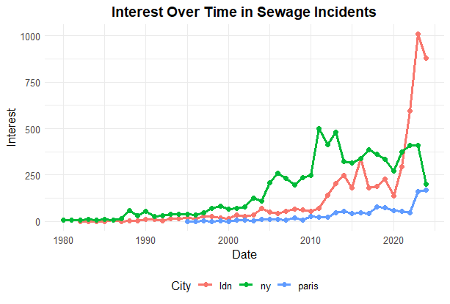
A1:
We see here the results from a search in English for London and New York and in French for Paris. Again, we see a unique surge in media attention towards sewage spills in London that is not observed in other developed countries’ capital cities. We note however, that Google Translate was used, and cultural and linguistic differences may mean these results are not directly comparable. Furthermore, this presents a longer time series, but it may not accurately reflect media interest in the past: LexisNexis is likely better at finding modern media articles than those a longer period of time ago. In any case, they supplement our findings with the more refined search conducted only for London and New York (Figure 1).

The searches conducted:
- hlead(London or Thames River or Thames Estuary) AND (sewage or wastewater or storm overflow or cso) AND (incident or event or spill)
- hlead(New York or Hudson River or Bronx River or East River) AND (sewage or wastewater or storm overflow or cso) AND (incident or event or spill)
- hlead(Paris OR Seine OR "Bassin de la Seine") AND (eaux usées OR eaux usées domestiques OR débordement d'orage OR débordement OR cso) AND (incident OR événement OR déversement)

Each search was, again restricted to return only results published in the respective country.

A2
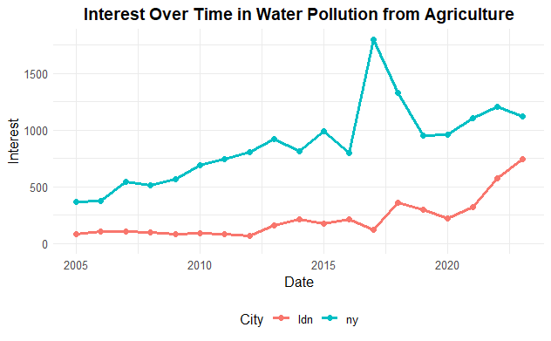
We here present media interest in diffuse agricultural pollution of waters for both the USA (blue) and the UK (red). We see in both a gradual upward trend

The search conducted (separately for the UK and US:
(water pollution) AND ((agriculture) OR (agricultural runoff) OR (rural land management))

The LexisNexis searches were conducted on 28th August 2024. Both the search for sewage spills in London and New York were designed to allow the results to be comparable between the cities and to eliminate false positive articles. For London: “hlead(London OR Thames River OR Thames Estuary) AND (sewage spill OR sewage overflow OR storm overflow OR wastewater spill OR wastewater overflow OR cso discharge OR sewage discharge OR wastewater discharge) AND NOT (improvement OR milestone OR praise). The same search was conducted for New York, simply replacing the first argument with “hlead(New York OR Hudson River OR East River)”. Each search was limited to return only articles published in the relevant country (UK or USA). Another, less optimised search was conducted also in French to compare Paris with London and New York. These results are presented in A1 and largely corroborate our findings in Figure 1.
Part of the EU’s Water Framework Directive (WFD), River Basin Management Plans (RBMPs) are made on a 6-yearly cycle and detail measures to manage water quality in a river basin district (Environment Agency, 2023)

